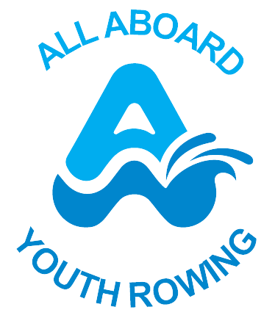

All Aboard Youth Rowing
Anti-Bullying and Harrassment Policy

1. Statement of Intent
This policy applies to everyone involved with the charity — including trustees, staff, volunteers, coaches, and participants — and covers all settings where the charity operates, both in-person and online.
This policy is written in conjunction with the following leglisation and guidance:
- Children Act 1989 & 2004
- Equality Act 2010
- Working Together to Safeguard Children (2023)
- Keeping Children Safe in Out-of-School Settings (DfE 2020, updated 2024)
- UK Sport / CPSU Anti-Bullying Guidance
All Aboard Youth Rowing Rowing is committed to providing a caring, friendly, and safe environment for all its Trustees, coaches, staff and volunteers so that they can work in a relaxed and secure atmosphere.
Bullying of any kind is unacceptable in rowing. Children, young people, and adults can all be targets for bullying and can carry out bullying.
All bullying should be taken seriously and investigated properly. If bullying does occur, all individuals should be able to tell someone and know that incidents will be dealt with promptly and effectively. This means that anyone who knows that bullying is happening is expected to tell the Trustee responsible for Safeguarding as soon as they have concerns.
All Aboard Youth Rowing takes bullying seriously. Anyone involved should be assured that they will be supported when bullying is reported.
Very simply, bullying will not be tolerated.
2. What is Bullying?
There is no legal definition of bullying. However, it is usually defined as behaviour that is:
- repeated
- intended to hurt someone either physically or emotionally
- often aimed at certain groups, e.g. because of race, religion, gender, sexual orientation, disability, family situation, or anyone considered to be ‘different’
Bullying takes many forms and can include:
- physical assault
- social bullying such as teasing
- threatening behaviour
- name calling
- cyberbullying - bullying via social networking sites, chat rooms, or anywhere online with abusive comments, sharing images without consent, hacking, spreading malicious rumours or pressurising someone to do something they do not want to do.
Bullying is not the same as banter.
Banter can be a mutually enjoyable ice breaker or release from stress in the sporting context. Unfortunately, the term 'banter' is sometimes used as an excuse for socially unacceptable behaviour and language and bullying.
We should all recognise that, just because a person does not intend their comments or behaviours to be seen as bullying, it does not mean they cannot be received as that.
All online activity associated with the charity — including social media, messaging apps, and group chats — must follow the organisation’s Social Media Policy. Inappropriate online behaviour may lead to disciplinary action.
3. Why is it important to respond to bullying?
Bullying hurts. No one deserves to be a victim of bullying. Everybody has the right to be treated with respect. It may not be your role to investigate whether abuse and/or bullying are taking place, but everyone involved with All Aboard Youth Rowing has a responsibility to respond promptly and effectively to issues of bullying.
In all cases we should act quickly so that the bullying behaviour or threats of bullying, can be investigated and the bullying stopped.
All staff, trustees and volunteers share a collective responsibility to challenge bullying and report concerns promptly.
4. Objectives of this Policy
Everyone involved with All Aboard Youth Rowing should have an understanding of what bullying is.
Everyone involved with All Aboard Youth Rowing should know the Charity’s approach to bullying and should be aware of the Charity’s policy and follow it when bullying is reported.
5. Procedures
All reports of bullying along with supporting evidence should be passed to the Trustee responsible for Safeguarding .
The Trustee responsible for Safeguarding, at the date of this document, is Elaine Nesbitt.
Where bullying concerns children or adults at risk, the Trustee responsible for Safeguarding should follow safeguarding procedures.
Where bullying is between adults, this is a breach of the Code of Conduct and should be addressed in line with the disciplinary and grievance procedures.
If the bullying involves a member of All Aboard Youth Rowing’s staff, then a grievance should be raised with All Aboard Youth Rowing’s Trustee Board.
In cases of serious bullying and you are concerned that someone is threatened with violence or harm then you should contact the police
6. Recommended Action
Usually, an informal attempt may be made to help the bully/bullies change their behaviour, which could involve mediation.
If the informal route, including mediation fails or is inappropriate under the circumstances and the bullying continues, the charity’s usual procedure on receiving a complaint, including, where appropriate, its disciplinary procedure, should be followed.
Drafted/Updated | Approved | Review
February 2024 | Yes | February 2025
February 2025 | Yes | February 2026
All Aboard Youth Rowing (1176153)

