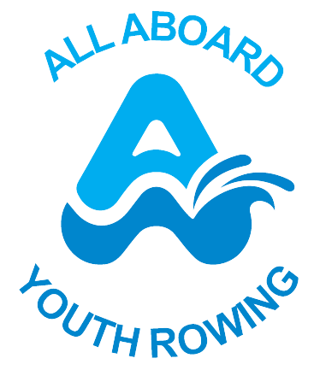

All Aboard Youth Rowing
Social Media Policy and Online Conduct Policy
Charity No. 1176153
Updated: November 2025
Next Review: November 2026
Version 1.2

1. Purpose
All Aboard Youth Rowing uses social media to promote, educate, fundraise, and support the development of youth rowing in the North West. This policy provides guidance to staff and volunteers on the appropriate and responsible use of social media, ensuring compliance with UK law, safeguarding principles, and the charity’s values of respect, professionalism, and inclusivity.

2. Legal Responsibilities
Use of social media is governed by UK law, including but not limited to the Equality Act 2010, Data Protection Act 2018, Defamation Act 2013, Communications Act 2003, and the Online Safety Act 2023. We will not post, share, or repost any content that may constitute or encourage:
• Harassment, threatening, or menacing behaviour.
• Grossly offensive or discriminatory comments.
• Libel or defamation.
• Breaches of data protection or privacy.
• Copyright or intellectual property infringement.

3. Safeguarding and Child Protection
All social media activity must comply with our Safeguarding Policy. Staff and volunteers must not contact children or young beneficiaries through personal accounts or private messaging. Images, videos, or identifying information of children or vulnerable adults may only be posted with written parental or guardian consent. Any concerning online behaviour must be reported immediately to the Designated Safeguarding Lead (DSL).

4. Online Safety and Data Protection
All Aboard Youth Rowing complies with Ofcom’s Online Safety regulations and the Information Commissioner’s Office (ICO) Children’s Code. We ensure that all platforms used by the charity are age-appropriate, respect privacy settings, and promote the safety and wellbeing of children and young people.

5. Official Spokespeople
Only designated spokespeople may speak on behalf of All Aboard Youth Rowing. If you are unsure whether you are authorised to represent the charity publicly, check with the CEO before commenting. Staff and volunteers are personally responsible for all content they publish and must ensure that personal opinions are not mistaken as those of the charity.

6. Conduct and Tone
When posting on social media in connection with All Aboard Youth Rowing:
• Remain courteous, factual, and respectful.
• Avoid political bias or party-political endorsement.
• Do not post content that could damage the charity’s reputation or appear to endorse smoking, alcohol misuse, or inappropriate behaviour.
• Clearly state when opinions are personal, e.g., 'Views are my own.'
• Use inclusive and professional language consistent with our charity’s tone of voice.

7. Authenticity and AI-Generated Content
We will not create, share, or engage with AI-generated or deepfake content that misrepresents individuals, beneficiaries, or events. All content shared by the charity must be authentic, accurate, and verifiable.

8. Accessibility and Inclusion
All posts must meet accessibility best practices, including the use of alternative text (alt text) for images, subtitles or captions for video content, and clear, easy-to-read language to ensure our communications are inclusive to all.

9. Moderation of Posts
The charity encourages open, honest, and respectful discussion online. Posts or comments will only be removed if they:
• Break the law or contain hate speech, harassment, or discrimination.
• Include personal attacks, defamation, or explicit language.
• Are irrelevant to the charity’s mission.
The CEO has authority for immediate take-down of unacceptable posts. All removals must be documented with a screenshot or record of the post.

10. Reputational and Crisis Management
If a post attracts significant negative attention or media interest, staff and volunteers must not respond independently. The CEO or Communications Lead will manage any official response in line with the charity’s communications policy.

11. Personal Social Media Use
Staff and volunteers must uphold the charity’s values online even when using personal social media accounts. Those identifying as part of All Aboard Youth Rowing must avoid sharing or engaging with inappropriate, offensive, or controversial material.

12. Compliance and Disciplinary Action
Failure to comply with this policy may result in disciplinary action in line with the Staff and Volunteer Conduct Policy. Serious breaches may also result in referral to external authorities or regulatory bodies.

13. Distribution
This policy must be shared with all new staff and volunteers upon appointment and revisited during annual safeguarding or digital communications training.

Version Control
Version 1.2 – Updated November 2025 – Includes Online Safety Act, safeguarding, accessibility, and AI content updates.
Approved by: Board of Trustees
Next Review: November 2026

